1. Open the first screen of your app by right clicking on it, then selecting “GUI Builder” :

Level of difficulty:   
Estimated time: 5 mn

[**www.codapps.io**](http://www.codapps.io)by Clement Levallois **@codapps_io** [**www.coursera.org/learn/codapps**](http://www.coursera.org/learn/codapps)



**Module 2: How to add text, pics, links etc. to your app**

*How to add a link to a webpage to your app*

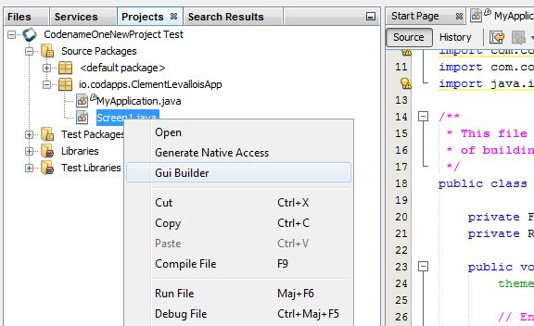

**1. Right click on the name of your screen**

**2. Select « GUI Builder »**

1. This opens a new window, which should look like this:

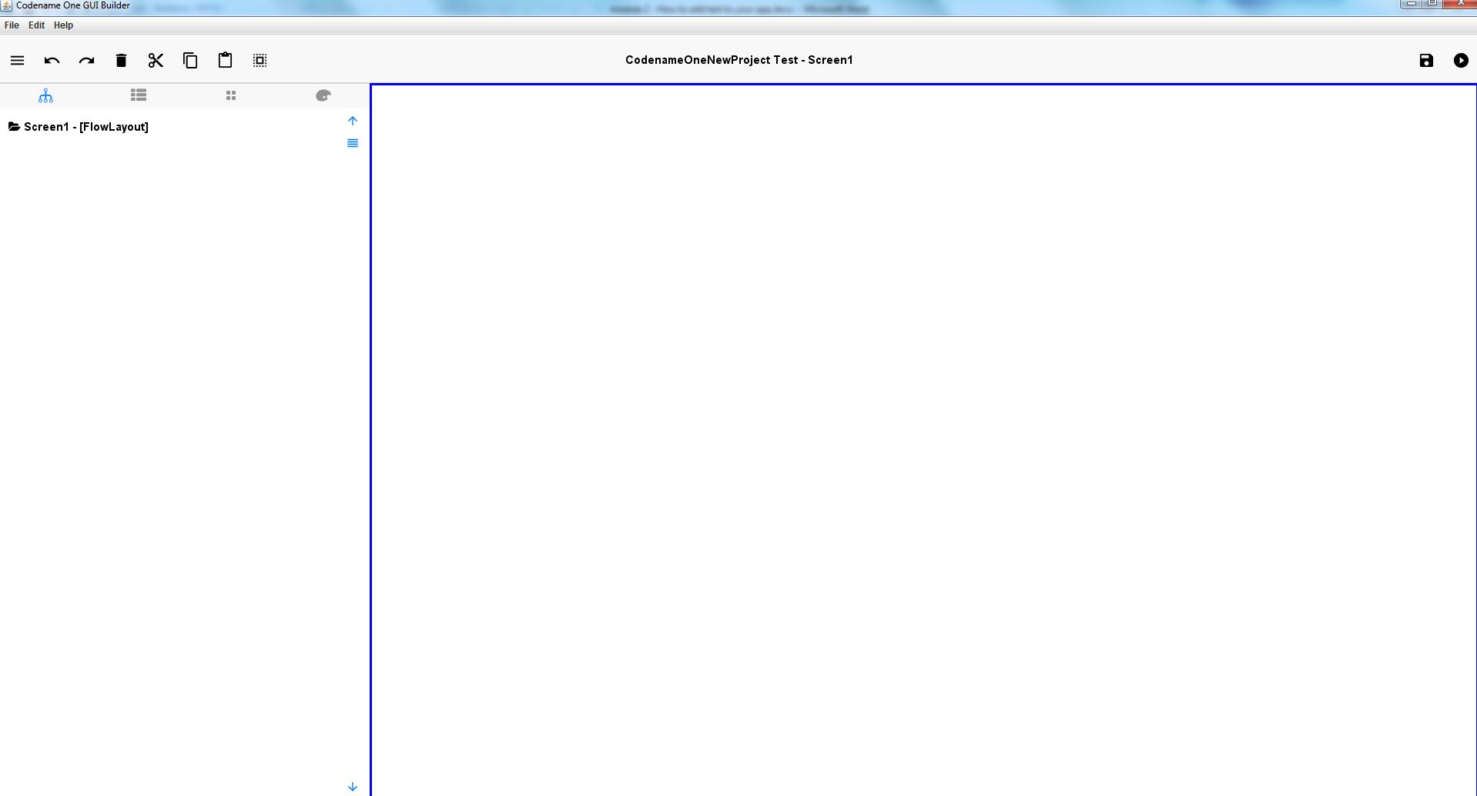

1. To add some a link to a webpage :

Level of difficulty:   
Estimated time: 5 mn

**Module 2: How to add text, pics, links etc. to your app**

*How to add a link to a webpage to your app*

[**www.codapps.io**](http://www.codapps.io)by Clement Levallois **@codapps_io** [**www.coursera.org/learn/codapps**](http://www.coursera.org/learn/codapps)



1. 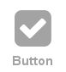Click on the “Palette” icon ( ). This shows everything you can use to put on a screen of your mobile apps.
2. Drag and drop the .Button icon ( ) to the screen on the right.
3. You now see the Button on your screen.

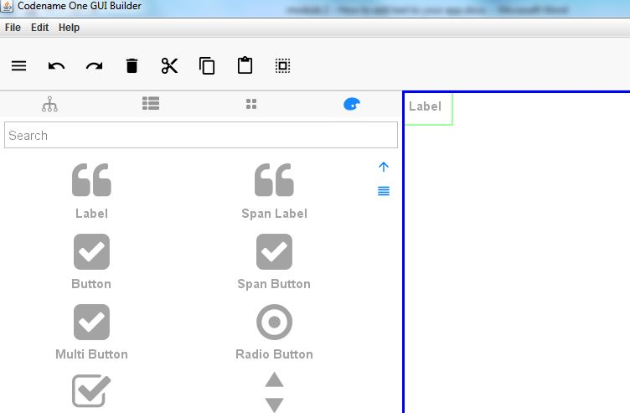

**c) after the drag and drop, you should see the button here, on your screen!**

**b) drag and drop the Label to the screen**

**a) Click on this icon**

1. You can change the text on the butto: select the Button, go to its properties, by clicking on the “Porperties sheet” icon ( ) and then changing the “Text” line.
2. Adding an action: when the user clicks on the button, a webpage opens.

Level of difficulty:   
Estimated time: 5 mn

Here we will have to add one line of code. No need to understand the logic, just copy paste it. We will learn how coding works in the module 5.

1. Select the Button on the screen by clicking on it. **You know it is properly selected when it has green borders**:
2. Click on the “property sheet” icon ( ) to see the properties of the button.
3. At the bottom of the panel, click on “Events”:

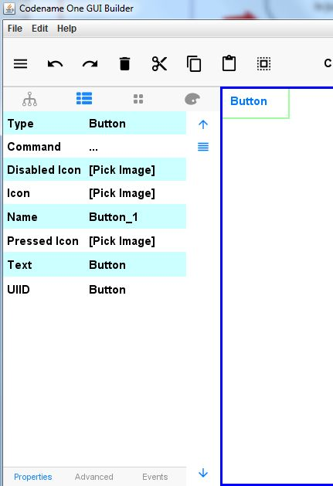



[**www.codapps.io**](http://www.codapps.io)by Clement Levallois **@codapps_io** [**www.coursera.org/learn/codapps**](http://www.coursera.org/learn/codapps)



**Module 2: How to add text, pics, links etc. to your app**

*How to add a link to a webpage to your app*

1. In the window that opens, click on “Action Event”:

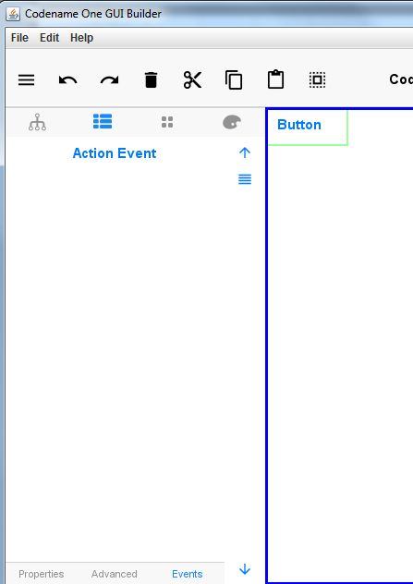

**click here**



[**www.codapps.io**](http://www.codapps.io)by Clement Levallois **@codapps_io** [**www.coursera.org/learn/codapps**](http://www.coursera.org/learn/codapps)



**Module 2: How to add text, pics, links etc. to your app**

*How to add a link to a webpage to your app*

Level of difficulty:   
Estimated time: 5 mn

What does it do? Basically, when you clicked on “Action Event”, it has written a couple of lines of code in the app, saving you the time of effort of writing it yourself. These lines of code are instructing the app to “do something” each time the button is clicked.

But to do what exactly? Anything you want. Here, you want that clicking on this button triggers the opening of a webpage. So we will go to the code of the app and add one line of code explaining which web page should be opened. See next page:

1. Telling the app which webpage should open when the button is clicked

* First, start by saving the Screen we were working on (File -> Save)

[**www.codapps.io**](http://www.codapps.io)by Clement Levallois **@codapps_io** [**www.coursera.org/learn/codapps**](http://www.coursera.org/learn/codapps)



**Module 2: How to add text, pics, links etc. to your app**

*How to add a link to a webpage to your app*

Level of difficulty:   
Estimated time: 5 mn

* Now, go back to NetBeans, and double click on the Screen1 file:
* On the right, scroll down to find the lines mentioning onButton_1ActionEvent:

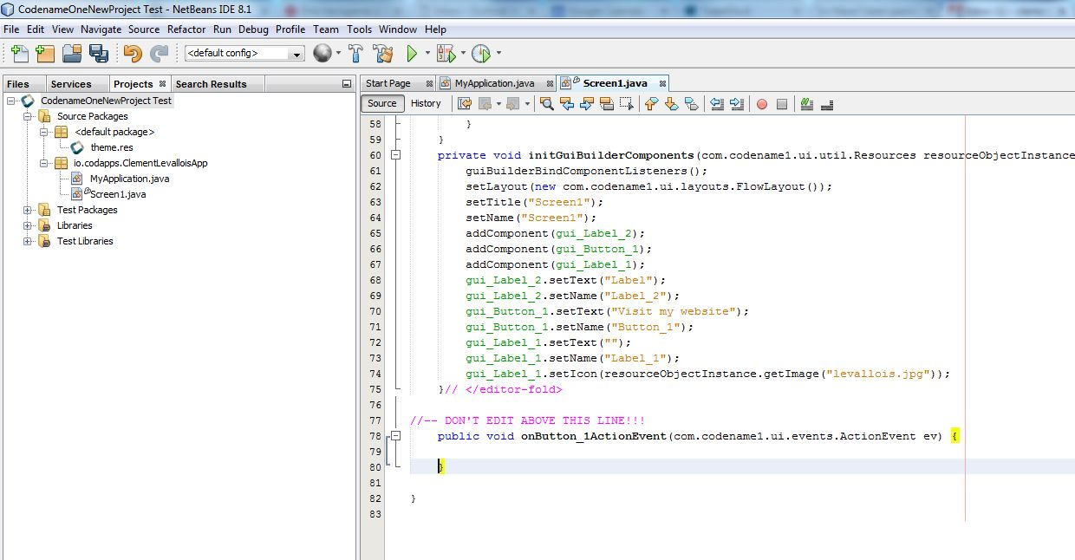

1. double click on « Screen1.java »

2. scroll down to see these lines of code

Between the curly braces { }, paste this line of code:

Display.getInstance().execute("http://www.clementlevallois.net");

So the code at the bottom of the file should look like:

//-- DON'T EDIT ABOVE THIS LINE!!!

public void onButton_1ActionEvent(com.codename1.ui.events.ActionEvent ev) {

Display.getInstance().execute("http://www.clementlevallois.net");

}

}

1. That’s it!

* To test your app, right click on the name of your project in NetBeans and select “Run”

[**www.codapps.io**](http://www.codapps.io)by Clement Levallois **@codapps_io** [**www.coursera.org/learn/codapps**](http://www.coursera.org/learn/codapps)



**Module 2: How to add text, pics, links etc. to your app**

*How to add a link to a webpage to your app*

Level of difficulty:   
Estimated time: 5 mn